**Chapter Six -- Dental Management in Chronic Medical Diseases**

**Introduction**

**The population of countries such as the United States is at higher risk to experiencing obesity, hypertension, cancers, cardiovascular and cerebrovascular diseases. In addition, periodontal disease is prevalent. As such, the role of the dental practitioner and hygienist must adapt and consider more than the immediate problems of caries, gingival inflammation, or aberrations in bone structure.**

**There have been publications suggesting that dentists can and should play a significant role in preventing or minimizing chronic medical diseases as well as in demonstrating a relationship between periodontal disease and chronic systemic diseases.**

**As such, an in-depth analysis of the relationships between dental and medical issues in these chronic diseases was warranted. This report employs an alternative text processing approach that is more transparent in function and in which quality-control can be more easily accomplished.**

**Traditionally, a review of the literature would involve acquisition of presumably pertinent documents, triaging of those documents for the relevant ones, identification and extraction of data from each document, and organization of those data for subsequent use. The procedures involved would be accomplished using some computerized assistance in retrieval and primarily manual, personal functions to accomplish the other tasks. These have been described as a paper-oriented process.**

**The explosive increase in scientific literature following the WW II led to consideration of more extensive computerized assistance. One such approach was labeled *text mining*. It involved the development of software to capture essential data from each retrieved document and to organize those documents based on the data.**

***Contextual Analysis* was introduced in 1979 and has been under study since that time. The employment of software in the identification, extraction, organization and utilization of the data resulted in a different type of analysis labeled – *Literature Analysis*.**

**Idea Record Construction**

**Exhibit 1 shows the result of the identification, extraction, and organization process. The informative terms within the first sentence are highlighted in red. These terms are arranged as pairs and entered into a data file. The idea records show these pairs (ideas) together with the location of the sentence. The identification number was assigned by PubMed and provides a portal for rapid retrieval of the document of interest. This identification and extraction process is effective in capturing the ideas expressed by the authors and facilitates use of those in building descriptions of existing knowledge (higher frequency and consistently expressed ideas) as well as strategies for development of new research.**

**Exhibit 1. Example of Sentence Containing Ideas and the Ensuing Data Records Included in the Idea Repository – Identification Number 19151554.**

**Source:** [**Silva AR**](http://www.ncbi.nlm.nih.gov/pubmed?term=Silva%20AR%5BAuthor%5D&cauthor=true&cauthor_uid=19151554)**1,** [**Alves FA**](http://www.ncbi.nlm.nih.gov/pubmed?term=Alves%20FA%5BAuthor%5D&cauthor=true&cauthor_uid=19151554)**,** [**Antunes A**](http://www.ncbi.nlm.nih.gov/pubmed?term=Antunes%20A%5BAuthor%5D&cauthor=true&cauthor_uid=19151554)**,** [**Goes MF**](http://www.ncbi.nlm.nih.gov/pubmed?term=Goes%20MF%5BAuthor%5D&cauthor=true&cauthor_uid=19151554)**,** [**Lopes MA**](http://www.ncbi.nlm.nih.gov/pubmed?term=Lopes%20MA%5BAuthor%5D&cauthor=true&cauthor_uid=19151554)**. Patterns of demineralization and dentin reactions in radiation-related caries.** [**Caries Res.**](http://www.ncbi.nlm.nih.gov/pubmed/?term=19151554) **2009;43(1):43-9. doi: 10.1159/000192799. Epub 2009 Jan 19. PMID: 19151554.**

**Sentence 1: *Radiation-related caries is a unique form of rampant decay and is a complication of head and neck radiotherapy that frequently causes generalized dental destruction and impairs quality of life in cancer patients.***

**Idea Records:**

|  |  |  |  |  |
| --- | --- | --- | --- | --- |
| **Primary** | **Related** | **Year** | **Ident** | **Sentence** |
| **Cancer** | **caries** | **2009** | **19151554** | **1** |
| **Cancer** | **cause** | **2009** | **19151554** | **1** |
| **Cancer** | **dental** | **2009** | **19151554** | **1** |
| **Cancer** | **life** | **2009** | **19151554** | **1** |
| **Cancer** | **radiation** | **2009** | **19151554** | **1** |
| **Cancer** | **radiotherapy** | **2009** | **19151554** | **1** |

**The ideas shown illustrate two important cognitive capabilities:**

1. **Each pair of terms is a fact of the following type – *Authors Silva et al in document 19151554, presented the relationship between cancer and a related term.* This fact was presented in sentence 1. With this information, precise retrieval of the document can be accomplished simply by entering the document ID number into the search box at PubMed.(**[**http://www.pubmed.gov**](http://www.pubmed.gov)**)**
2. **The meaning of the term, cancer, is elaborated by considering the related terms. For example, a statement such as the following is possible – *In head and neck cancer treated with radiotherapy, a significant adverse effect is the occurrence of caries.***

**This linkage between *cancer, radiotherapy*, and *caries* raises questions such as:**

1. **Are there alternative forms of cancer treatment that would be effective without the adverse effect of caries?**
2. **If radiotherapy is adopted, are there preventive or minimizing approaches that could be employed to protect against caries?**

**Exhibit 2. Excerpt from Idea Database with Caries as the Central Term and Related Terms Considered by the Author-specialists. 1980-2013.**

|  |  |  |  |  |
| --- | --- | --- | --- | --- |
| **Primary** | **Related** | **Year** | **Ident** | **Sentence** |
| **caries** | **abscess** | **2010** | **21819682** | **5** |
| **caries** | **absence** | **2000** | **12618670** | **12** |
| **caries** | **absence** | **2005** | **17892037** | **3** |
| **caries** | **acid** | **2005** | **19341954** | **2** |
| **caries** | **acid** | **2013** | **22027069** | **6** |
| **caries** | **acid** | **2013** | **24242241** | **7** |
| **caries** | **acid** | **2013** | **24804050** | **3** |
| **caries** | **adolescent** | **2005** | **16443876** | **2** |
| **caries** | **adolescent** | **2005** | **17362627** | **5** |
| **caries** | **adolescent** | **2005** | **18158524** | **12** |
| **caries** | **adolescent** | **2005** | **18725052** | **3** |

**A preliminary approach in answering questions such as those would involve determining what has been attempted in the past. A traditional analysis of the available documents would be expected to take months of intensive effort. Busy practitioners have demonstrated a reluctance to expend that effort without promise of success. The presence of an idea database containing the essential data from the scholarly literature eliminates that burden. Exhibit 2 shows an excerpt from the idea database for ideas involving the combination of caries with related terms.**

**In this organization of ideas, caries was chosen as the central term. The terms linked with that central term are shown.**

**Exhibit 3. Excerpt from Terms Linked with the Central Term – Caries – Arranged to Show Importance Based on Frequency of Use. 1980-2013.**

|  |  |
| --- | --- |
| **Term** | **Freq** |
| **Caries Idea Set** | **1021** |
| **dental** | **121** |
| **diabetes** | **113** |
| **diabetic** | **83** |
| **disease** | **51** |
| **mellitus** | **40** |
| **oral** | **36** |
| **periodontal** | **36** |
| **risk** | **33** |
| **children** | **31** |
| **prevalence** | **29** |
| **age** | **25** |
| **metabolic** | **20** |

**Exhibit 3 shows the related terms linked with caries from this idea database. Each term was linked with the central term. The number of times each idea was cited is shown. One interpretation of these findings is importance of the idea. The more frequently used implies the more important the idea was to the authors. As seen, the authors contributing documents dealing with caries linked diabetes, periodontal disease, and children as higher risk. The higher frequency ideas (i.e., more important?) did not include treatments or preventive measures. Prevention (14/1021 ideas), hygiene (13) and periodontitis (13) were cited less frequently. Fluoride (6/1021) and toothpaste (1) were additional dental treatments considered.**

**Advantages of Using Ideas**

**These ideas and the relationships among them considered by authors serve two important functions:**

1. **They describe the present situation regarding the particular topic of interest (i.e., caries).**
2. **They serve as portals for new questions and answers. As seen, the ideas linking caries did not expound on preventions. Indeed the link between caries and prevention was cited by authors only 14/1021 times. In the period between 1980 and 2013, that is about 0.4 times per year. In contrast, diabetes was cited with caries about 5.9 times per year.**

**Quadruplet Ideas**

**Exhibit 4 shows an excerpt of the combinations of the central terms – caries, diabetes, & prevent -- with related terms.**

**Exhibit 4. Terms linked with the Three Central Terms – Caries, Diabetes, and Prevent – 1980-2013.**

|  |  |  |  |  |  |  |
| --- | --- | --- | --- | --- | --- | --- |
| **Caries** | **Diabetes** | **Prevent** | **Related** | **Year** | **Ident** | **Sentence** |
| **caries** | **diabetes** | **prevent** | **adverse** | **2000** | **15641324** | **16** |
| **caries** | **diabetes** | **prevent** | **american** | **2005** | **18158524** | **12** |
| **caries** | **diabetes** | **prevent** | **behavior** | **2005** | **18158524** | **12** |
| **caries** | **diabetes** | **prevent** | **cancer** | **2000** | **15153687** | **11** |
| **caries** | **diabetes** | **prevent** | **dental** | **2000** | **15641324** | **16** |
| **caries** | **diabetes** | **prevent** | **dental** | **2005** | **15964535** | **12** |
| **caries** | **diabetes** | **prevent** | **dental** | **2005** | **18158524** | **12** |
| **caries** | **diabetes** | **prevent** | **dental** | **2005** | **19255175** | **9** |
| **caries** | **diabetes** | **prevent** | **dental** | **2013** | **23076036** | **2** |
| **caries** | **diabetes** | **prevent** | **dental** | **2013** | **23076036** | **7** |
| **caries** | **diabetes** | **prevent** | **dental** | **2005** | **23994809** | **1** |
| **caries** | **diabetes** | **prevent** | **dental** | **2013** | **24804050** | **22** |
| **caries** | **diabetes** | **prevent** | **disease** | **2000** | **15153687** | **11** |
| **caries** | **diabetes** | **prevent** | **disease** | **2005** | **18158524** | **12** |
| **caries** | **diabetes** | **prevent** | **disease** | **2005** | **19255175** | **9** |

**These more complex ideas consist of three central terms plus a related one. It is important to reiterate that the four terms involved in each idea were provided by the author within the domain of a sentence. These ideas more closely approximate concepts. In addition, the specificity of the idea enhances the impression that these ideas were considered more important to the authors.**

**Exhibit 5. Excerpt of Frequency of Related Terms in the Idea Base Consisting of Quadruplet Ideas – Caries, Diabetes, Prevent & Related Term. 1980-2013.**

|  |  |
| --- | --- |
| **Term** | **Freq** |
| **Quadruplet Ideas** | **46** |
| **dental** | **8** |
| **disease** | **3** |
| **obesity** | **3** |
| **oral** | **3** |
| **health** | **2** |
| **hygiene** | **2** |
| **insulin** | **2** |
| **progression** | **2** |
| **risk** | **2** |
| **adverse** | **1** |
| **american** | **1** |
| **behavior** | **1** |
| **cancer** | **1** |

**Exhibit 5 shows an excerpt of the frequency of ideas linking the central three terms – caries, diabetes, and prevent – with a fourth term. The number of ideas decreased from the1021 total involving caries to the 46 involving the central three. The first dental treatment was hygiene with 2/46. The more frequent ideas included obesity (3) and health (2) with dental being most frequent with 8/46.**

**The documents containing the quadruplet involving dental were retrieved to see how the authors used the idea. Two of the ideas describe effects in mice. The remaining ideas involved the use of sweeteners in preventing caries. None of the eight dealt with clinical care of patients with caries and diabetes.**

**Temporal Use of Ideas**

**The total set of ideas from the dental and chronic medical disease documents was organized by time periods in order to determine:**

1. **The presumed importance of terms based on the frequency of their use as central terms in ideas.**
2. **The relative importance of dental, medical, or more descriptive terms in forming descriptions.**

**Exhibit 6 shows the temporal use of ideas. The total number of ideas in the decade 1980-89 was in excess of 74,000. The four year period – 2010-2013 – yielded over one-half million ideas. Age was the term involved in the largest number of ideas, 47,211. This was followed by cell (47,139), oral (46750), disease (41390), dental (36616), and gene (30,938). The first disease identified was cancer with 28,318 ideas. Periodontal and periodontitis were the first dental conditions identified with respectively, 20,900 and 13,286 ideas. Temporally, the terms increased from lows in the period 1990-9 to highs in the period 2010-2013.**

**Exhibit 6. Excerpt from Terms and Frequency of Ideas for Each Time Period. 1980-2013.**

|  |  |  |  |  |  |  |
| --- | --- | --- | --- | --- | --- | --- |
| **Term** | **1980-9** | **1990-9** | **2000-4** | **2005-9** | **2010-13** | **Total** |
| **Total Ideas** | **74462** | **69266** | **228150** | **323618** | **536457** | **1231953** |
| **age** | **2959** | **2601** | **8858** | **12053** | **20740** | **47211** |
| **cell** | **2677** | **3550** | **9677** | **9950** | **21285** | **47139** |
| **oral** | **2197** | **2422** | **9308** | **10464** | **22359** | **46750** |
| **disease** | **2343** | **1463** | **7250** | **12592** | **17742** | **41390** |
| **dental** | **3342** | **1847** | **6500** | **9843** | **15084** | **36616** |
| **gene** | **1351** | **1615** | **5989** | **7775** | **14208** | **30938** |
| **cancer** | **892** | **1238** | **5499** | **4615** | **16074** | **28318** |
| **health** | **920** | **589** | **3594** | **6720** | **10489** | **22312** |
| **chronic** | **1173** | **602** | **4282** | **6729** | **8580** | **21366** |
| **periodontal** | **818** | **400** | **3604** | **7126** | **8952** | **20900** |
| **risk** | **689** | **664** | **3228** | **4952** | **8455** | **17988** |
| **tumor** | **877** | **1451** | **4133** | **2936** | **8570** | **17967** |
| **infect** | **1243** | **860** | **3624** | **4535** | **6308** | **16570** |
| **cause** | **1058** | **797** | **2768** | **3970** | **5916** | **14509** |
| **periodontitis** | **302** | **88** | **2443** | **4449** | **6004** | **13286** |

**Caries Management**

**Caries related ideas occurred 6,544 times. Figure 1 shows the higher frequency terms linked with this central term for the period 1980 – 2013. There were several clusters of ideas. One was the ideas describing oral issues associated with caries. Those ideas focused on dental structural aspects. Another cluster described the diseases associated with**

**Figure 1. Higher Frequency Terms Linked with the Central Term – Caries – 1980-2013.**

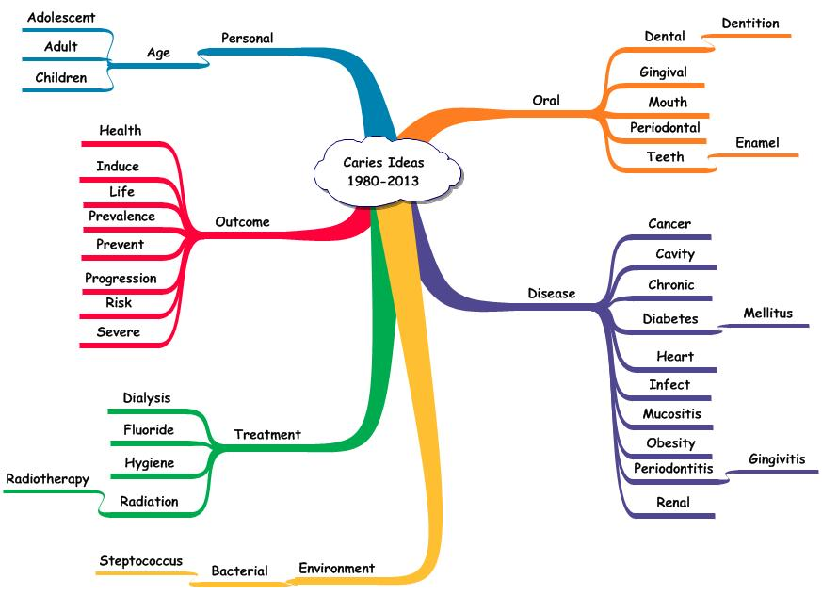

**caries. These could be summarized as including immuno-compromised patients. A third cluster described the results of management and included ideas dealing with status, failure and, of particular interest, prevention. A fourth cluster dealt with treatments. Radiation therapy and dialysis were relevant in occurrence of caries in patients with oral cancer or kidney disease. The other treatments identified – hygiene and fluoride -- dealt with approaches in attempting to deal with caries occurrence. The diseases linked with caries included diabetes, cancer, heart disease, obesity, renal disease, and periodontal disease.**

**These higher frequency terms, each linked with caries, provide a description of the structure and function of caries disease. The established treatment protocol for caries is not mentioned suggesting that this treatment approach is well established.**

**Caries and Cancer or Caries and Tumor as the Central Ideas**

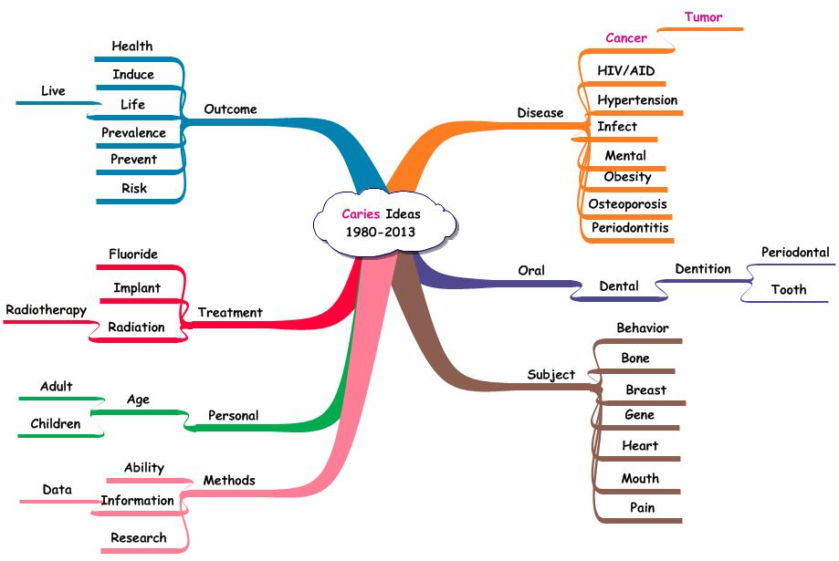**Figure 2. Terms Linked with the Central Ideas – Caries and Cancer and Caries and Tumor.**

**There were 701 ideas involving the central idea – *caries and cancer or caries and tumor* – in the 1980-2013 literature dealing with dental care and chronic diseases. There was a paucity of clinical studies and a majority of opinion-type publications. Figure 2 shows the higher frequency ideas dealing with these central ideas. The central ideas were caries and cancer and caries and tumor. These links are shown in red. Radiation treatment was identified as a cause of caries in patients with oral cancers. Radiation also was implicated in implant failure. The use of fluorides was identified but not formally studied. Prevention of caries was considered but again not as clinical trials.**

**Caries and Diabetes**

**Figure 3. Terms linked with the Central Pair – Caries and Diabetes – 1980-2013.**

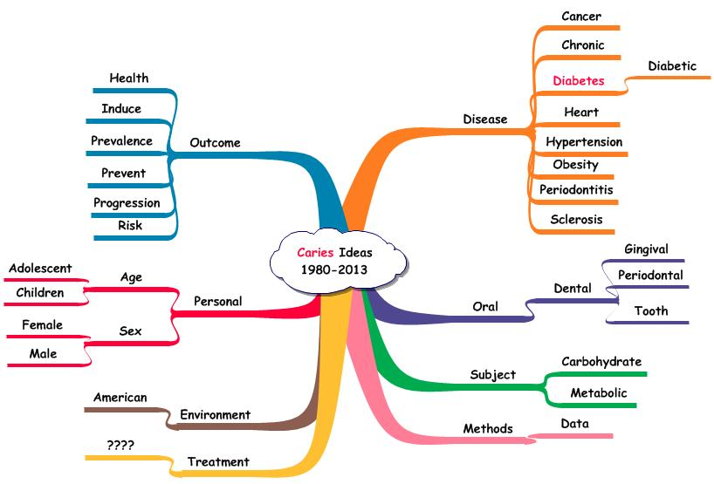

**Diabetes is a pandemic illness in the United States affecting persons of all ages. The ideas consisting of the pair – *caries and diabetes* – would be of interest in exploring the possibilities for new clinical research studies. There were 589 ideas from sentences containing the central idea for the period 1980-2013.**

**Figure 3 shows all of the ideas in this group that occurred 3 or more times. That filtering criterion eliminates the random ideas and focuses attention on the ideas that might have consensus agreement.**

**The cluster of ideas describing diseases linked with the central pair – *caries and diabetes* – in essence describes the millions of individuals who are at risk. Of particular interest is the *absence of treatments* suggesting that diabetologists, dentists, and related caregiving disciplines have not joined forces to deal with this problem with an evidence-based approach.**

**The outcome cluster of ideas contains one triad – *caries, diabetes, and prevent* – that might provide insights. The abstracts containing this idea numbered four and were published between 2004 and 2009. While authors recognized the importance of prevention of caries in diabetic patients or in those at risk to diabetes, the obvious studies have not been reported in the literature:**

1. **Comparison of anti-infection agents plus regular diet with anti-infection agents plus diabetic diet.**
2. **Comparison of sugar-free candy and gum plus regular diet with sugar-free candy and gum plus diabetic diet.**
3. **A more holistic approach involving monitored toothbrushing, plaque reduction, and sugar-free gum versus usual dental care.**

**Individuals eligible for such studies would range from overweight, ‘healthy’ individuals to diabetic patients.**

**Central Ideas – Caries with, respectively, Heart, Cardiac, and Coronary**

**There were 298 ideas associated with the three central ideas. Figure 4 shows the higher frequency ideas involved. The emerging pattern continues to be evident. Formalized clinical trials were not a standard of investigation. Instead, publications describe observations without presentation of formal study and resulting data. The treatments consisted of hygiene and vaccine intended to protect against bacteria causing caries.**

**Figure 4. Terms Linked with the Central Ideas – Caries and Heart, Caries and Coronary, and Caries and Cardiac – 1980-2013.**

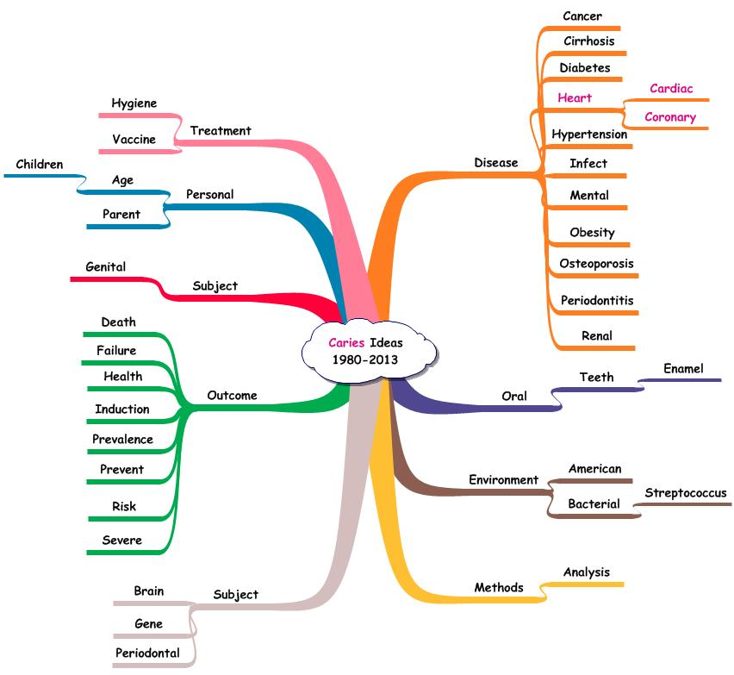

**Caries and Kidney Disease**

**There were 194 ideas associated with the central ideas – *caries and kidney and caries and renal*. The terms linked with these central ideas are shown in Figure 5.**

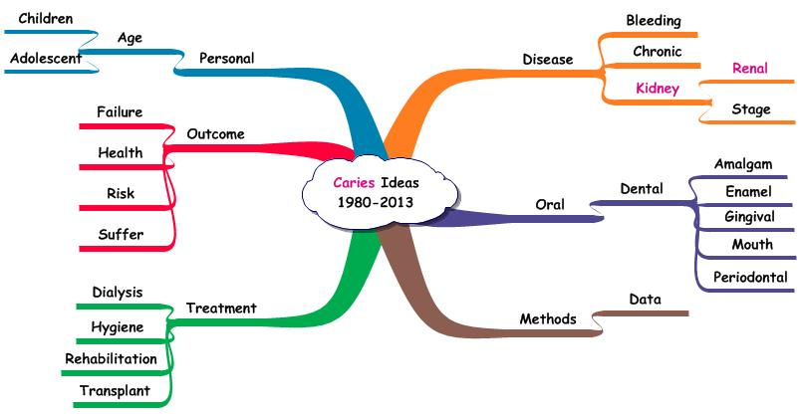**Figure 5. Terms Linked with the Central Ideas – Caries and Kidney and Caries and Renal – 1980-2013.**

**The ideas representing treatment primarily were focused on management of the kidney disease. The triadic idea involving hygiene with the central pairs represented an observational study.**

**The absence of studies dealing with dental management in advanced kidney disease is a concern. An established belief is that infections of any type are detrimental to the status of kidney disease. As such, clinical studies of treatments in dealing with caries and periodontitis would be of value.**

**The focus on the ideas and their interrelationships means that the massive amount of reading and triaging associated with processing of paper documents is eliminated. Learning involves the following:**

1. **Consideration of the total idea structure representing a topic.**
2. **Identification and evaluation of the important relationships (i.e., higher frequency ideas).**
3. **Development of explanations for the different ideas and their importance ranking.**
4. **Identification and evaluation of the low frequency ideas.**
5. **Exploration of the interfaces between the high and low frequency ideas.**
6. **Construction of arrangements of the ideas.**
7. **Selection of a particular one for further investigation.**

**Using computerized algorithms, these tasks are enhanced and the time and effort involved reduced. The effort formerly expended on acquisition and organization of the data can be shifted to understanding the criteria that could be used in selecting and organizing ideas to form either existing knowledge (the high frequency ones) or potential new knowledge (the integration of low and high frequency ideas). By building the idea structure and by developing the supporting rationale, the learning process is changed from one involving memorization of pre-packaged information to utilization of the higher cognitive functions. That process ensures long term memory of the vocabulary, ideas, and the procedures involved in the construction. This process enhances critical thinking by focusing on the *measures* involved in dealing with the ideas and the resulting structure, *criteria* involved in processing those measures, and the *decision-rules* involved in the evaluation and judgment functions.**

**The important questions in evaluating information can be addressed effectively and rapidly:**

1. ***What* are the issues involved?**
2. ***Why* are these issues important?**
3. ***How* were these issues derived?**
4. ***Who* provided the descriptions of these issues?**
5. ***Where* have these issues been studied?**

**Literature Analysis**

**This methodology is an extension of the systematic review process described in the Cochrane Collaboration. Text mining software is designed to identify the vocabulary used by authors and the ideas presented in their sentences. These data are captured, organized, and verified in ways similar to those used to validate numerical databases. Idea databases can be constructed more easily and these accurate and comprehensive resources can be used in ways again, similar to numerical databases. The shift from acquisition to utilization is time and energy savings. In addition, the focus on ideas and their use as independent building blocks means that individuals can spend about 90% of their effort in developing measures, criteria, and decision-rules relative to each higher order cognitive function (synthesis, comparison, evaluation, judgment, and application). These functions are the critical ones involved in creativity and in continual learning.**

**Gold Standards**

**In assessing a new methodology, the results of this process must be compared against a previously acceptable one. In testing the results of Literature Analysis, several gold standards have been employed:**

1. **Comparison with published findings/opinions from recognized specialists.**
2. **Acceptance of findings by peer-review groups. To do this, documents prepared using the Literature Analysis approach were submitted to reviewing groups without specifying the use of the method. In that way, the results could be evaluated assuming traditional procedures (personal and private mentation) had been used in developing the description of the existing knowledge as well as the strategies for generating new knowledge. Approval of these proposals suggested that the results of the formalized process matched and/or improved the results of the subjective ones.**
3. **Temporal analyses designed to trace ideas back in time to their origins. These ideas, prepared by specialists, were approved in funded research proposals, These analyses showed an objective path from first use to present use, and provided an alternative to the mysterious ‘eureka’ process previously used to explain innovation.**
4. **Temporal analyses designed to predict the use of an idea structure in the present based on organization of ideas through time. These analyses showed a path from individual elements (ideas) and their organization in developing a new research strategy. Such strategies were then compared with those proposed in newly funded research proposals.**

**Continual Learning**

**Research is a formalized approach to continual learning and as such is a critical component of individual development and achievement. However, the requirements placed on the individual in terms of time and effort may explain the dramatic reduction in formalized research in spite of the increase in scholarly publications. In dental management of chronic medical diseases, the difference between randomized and observation study use was significant. Similarly, formal, systematic literature reviews were used considerably less often than opinion pieces. The latter omitted details of process but successfully passed the filter of peer review.**

**There are different ‘research methodology’ lists but all involve the following tasks:**

1. **Retrieving and triaging possibly pertinent literature.**
2. **Extracting and organizing relevant data.**
3. **Synthesizing, comparing, and evaluating different constructs of the data.**
4. **Translating those appropriate procedures into new data capture capabilities.**
5. **Performing the data acquisition and editing.**
6. **Translating the findings into knowledge components.**
7. **Integrating those into a more comprehensive description of the topic.**

**Each of these tasks represents a significant amount of time in the life of the professional. Imagine the burden placed on the student who is faced with accomplishing each and learning the necessary theories and practices. As such, the research process is avoided wherever possible. This suggests that independent learning is accomplished by focusing on previously prepared packages of information rather than attempting to develop descriptions based on primary elements. Such learning is consistent with the procedures used throughout formal education.**

**The use of the authors’ ideas changes that tedious process into one that enhances creative actions. The first two items in the above list are performed by software *once* for a given set of documents. This means that the individual, professional or student, can begin with item three. That shifts time and effort from about 90% used on items #1 and #2 to 90% effort used on the higher cognitive functions. Developing different combinations of ideas, using computer-assisted algorithms, is a matter of minutes rather than hours, days, or months. Choosing a favored research strategy is based on a transparent process. Item four is simplified and accelerated by considering the appropriate syntheses of ideas. The conduct of new studies is enhanced by the acquisition of new data and the conversion of those elements to knowledge components. Those new or confirmatory ideas are easily integrated into the existing idea structure. The result is new knowledge. What traditionally took months can now be accomplished in hours. The burden of learning has been transformed into the exhilaration of achievement.**

**Shift in Processing – Shift in Perception**

**Making the acquisition, organization, and utilization of information easier and more transparent, involves incredibly simple tasks:**

1. **Separation of authors’ text into individual sentences.**
2. **Identification and extraction of informative terms (nouns, adjectives, gerunds).**
3. **Construction of idea records consisting of paired terms and bibliographic data.**
4. **Organizing those records using editing functions such as sorting and copying.**
5. **Combining ideas to form descriptions, new and existing.**

**With the idea resources appropriately verified, the process of knowledge utilization takes on a new vigor.**